U19 BOPSS Triathlon champs - Ohope

Swim course: 600m point to point swim with tidal assistance.
All athletes will be briefed & then walk to the start-line. The race will be a deep-water start. Swim directly to the buoy which will be just off the shore & turn right around the buoy then proceed to the shore.
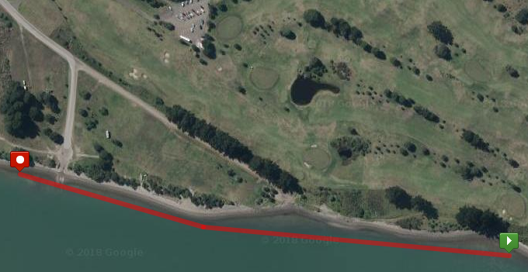

Bike course: 20km, 2 lap course around Ohope. Harbour Rd & Ocean Rd
Mount bike @ the line & proceed along Harbour Rd. Just past campground turn right into Charles St then left into Ocean Rd. follow this to the end & turn left into Te Akau St. Then turn left onto Pohutukawa Ave, staying left & via left into Harbour Rd. Make your way back to Charles St & turn left. Then complete a 2nd lap. On completion of 2nd lap you head straight back along Harbour Rd to the Dismount line to complete the cycle leg. Draft-legal
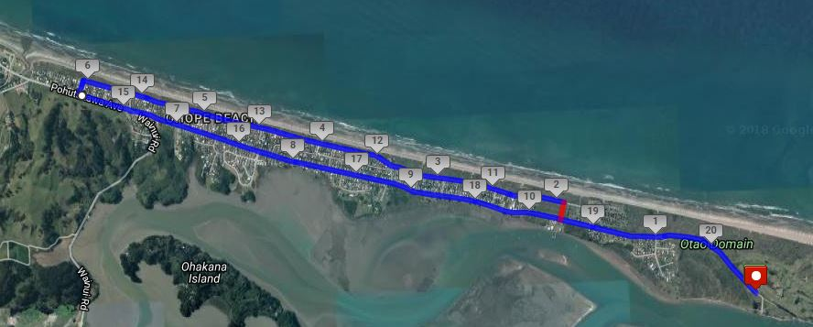

Run course: 4km Out & back along Harbour Rd
From the Transition area via left onto Harbour Rd & staying on the left-hand side of the road & proceed to the run turn-around cone. Then staying on the same side of the road make your way back along Harbour Rd then making a slight righthand turn into the Finish-line.
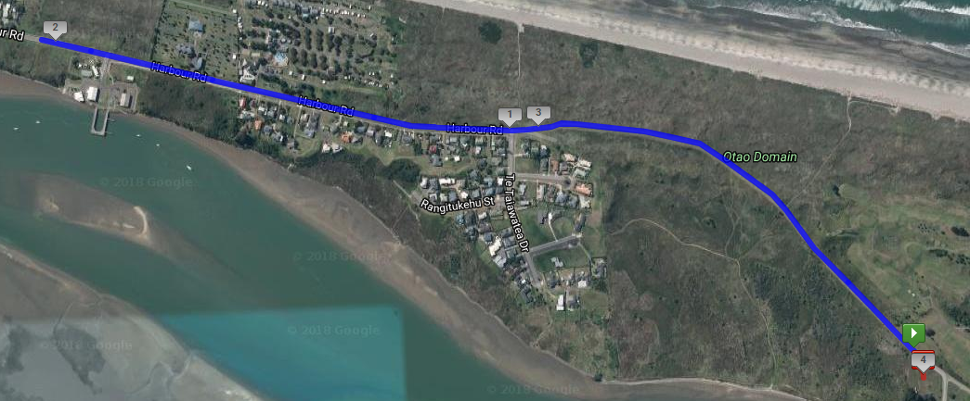
Transition Area: Enter from swim at the bottom end & exit on bike from the top end. Enter from the bike @ the top end & exit out the bottom end for the run & turn a sharp right to head up Harbour Rd.
