U13 BOPSS Triathlon champs - Ohope

Swim course: 250m point to point swim with tidal assistance.
All athletes will be briefed & then walk to the start-line. The race will be a deep-water start. Swim directly to the buoy which will be just off the shore & turn right around the buoy then proceed to the shore.
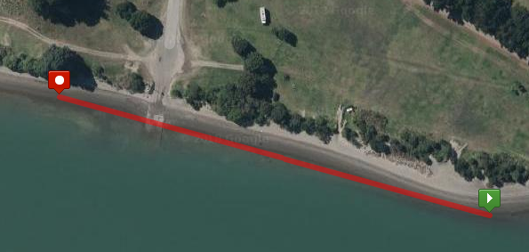

Bike course: 8km, 1 lap course around Ohope. Harbour Rd & Ocean Rd
Mount bike @ the line & proceed along Harbour Rd. Just past campground turn right into Charles St then left into Ocean Rd. Follow this to Tawai St & turn left. Then turn left onto Harbour Rd. Make your way back along Harbour Rd then you head straight back to the Dismount line to complete the cycle leg.
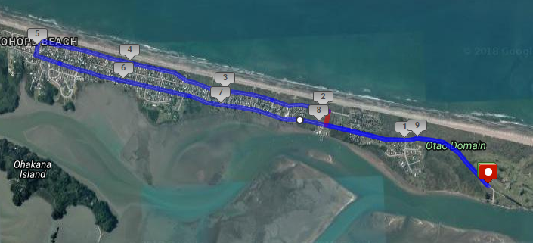

Run course: 2km Out & back along Harbour Rd
From the Transition area via left onto Harbour Rd & staying on the left-hand side of the road & proceed to the run turn-around cone. Then staying on the same side of the road make your way back along Harbour Rd then making a slight righthand turn into the Finish-line.
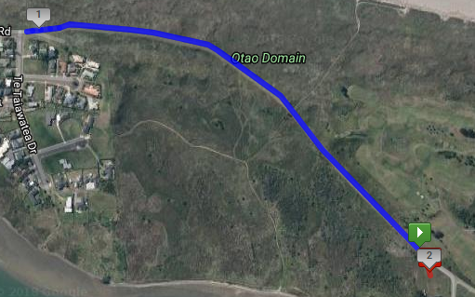
Transition Area: Enter from swim at the bottom end & exit on bike from the top end. Enter from the bike @ the top end & exit out the bottom end for the run & turn a sharp right to head up Harbour Rd.
